**Assignment:**

Write an ansible playbook to automate installation of MySQL 8.0 on a Linux machine.

Automate all the steps mentioned in the given links :

<https://www.digitalocean.com/community/tutorials/how-to-install-mysql-on-ubuntu-22-04>

[https://www.digitalocean.com/community/tutorials/how-to-move-a-mysql-data-directory-to -a-new-location-on-ubuntu-20-04](https://www.digitalocean.com/community/tutorials/how-to-move-a-mysql-data-directory-to%20-a-new-location-on-ubuntu-20-04)

**Prerequisites:**

1. Ansible ec2 instance (I have created it with Amazon Linux 2 AMI)
2. AWS ec2 instance- Ubuntu Server 22.04 & Ubuntu Server 20.04
3. Server root access or user with sudo access for ansible

**Servers:**

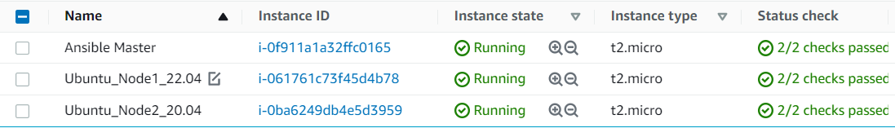

“Before proceeding further make sure you Linux systems are up to date”

**Implementation:**

Installation of Ansible:

1. amazon-linux-extras install epel -y
2. yum install ansible -y
3. Validate using : ansible --version

Made changes in ansible configuration files:

1. Update /etc/ansible/hosts for –
2. Taken backup before any changes

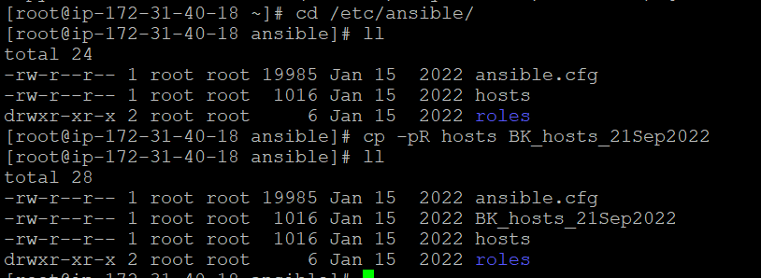

1. Create a server group where you have to install MySQL:

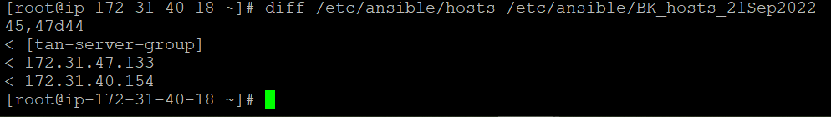

1. Uncomment required settings in ansible.cfg

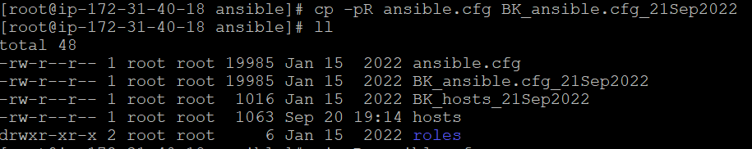

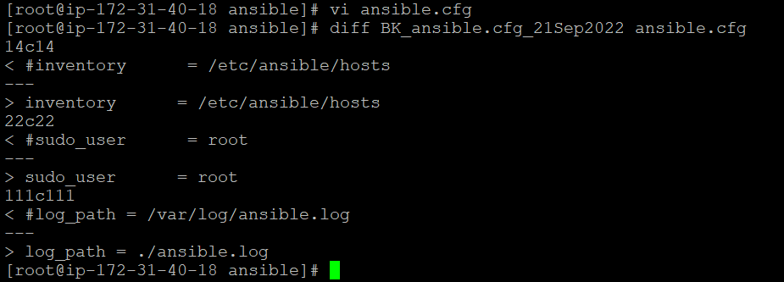

1. Creating ansible user as we don’t share root details with anyone or any device setup.

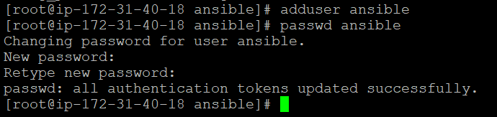

1. Similarly created ansible user in other two nodes.
2. Added root privileged to the ansible user in all nodes.

Ansible Master:

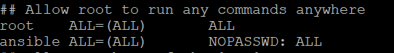

Ubuntu_Node1_22.04 & Ubuntu_Node2_20.04:

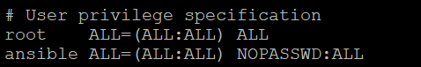

1. Establish Password less Authentication between Master & the Client –
2. Update sshd_config:

Ansible-

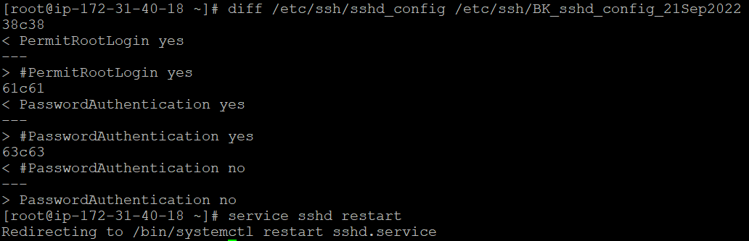

Both client nodes:

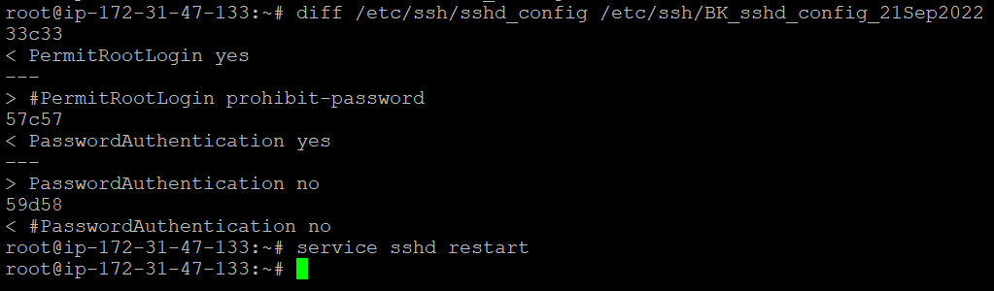

1. Using ssh-keygen generate an SSH key pair on all the servers and then copy-paste ***~/.ssh/id_rsa.pub (***public key) content from Ansible Master server to all client servers **.ssh/authorized_keys** file.
2. Once done, validated if able to login to client server from Ansible Master.
3. Executed Ansible Playbook from Ansible master :

**ansible-playbook setup-mysql.yml**

**Note:**

* For mysql_secure_installation script path instead of script we divided those script task in playbook as –
  + set the root password
  + remove anonymous users
  + remove root remote access
  + remove the test database
* Reference taken from:

https://dev.mysql.com/doc/refman/5.7/en/mysql-secure-installation.html

**Outcomes:**

Terminal Execution –

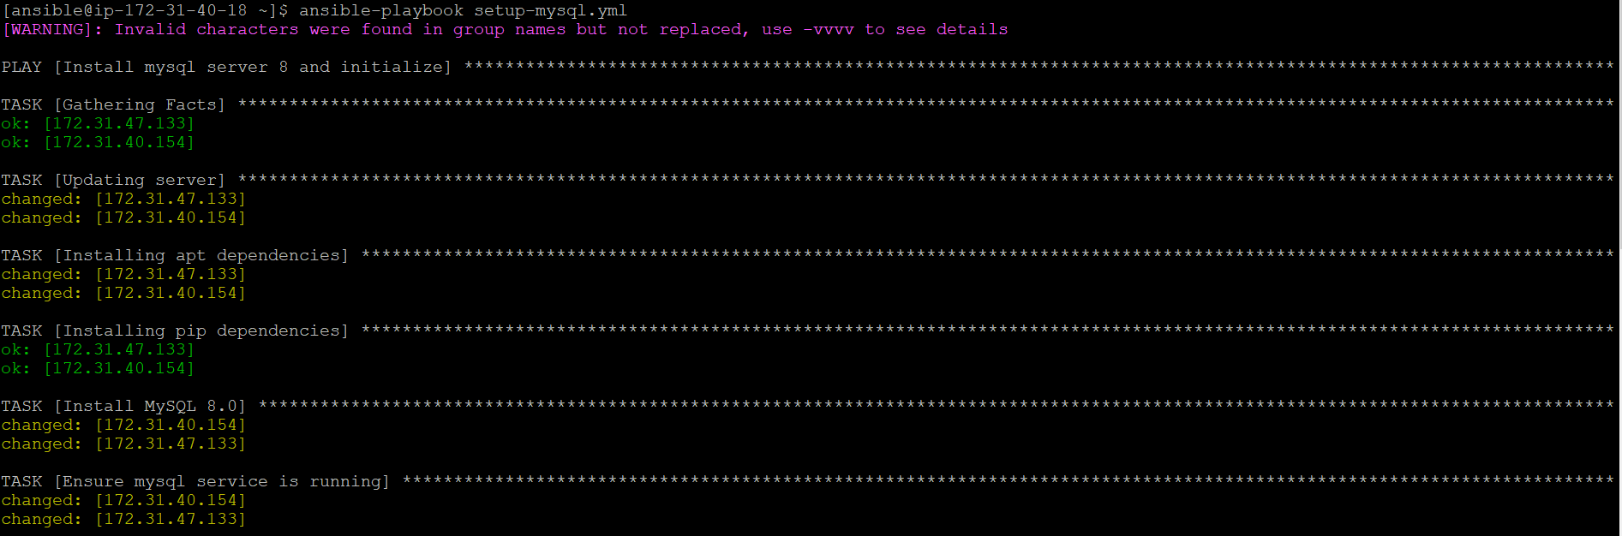

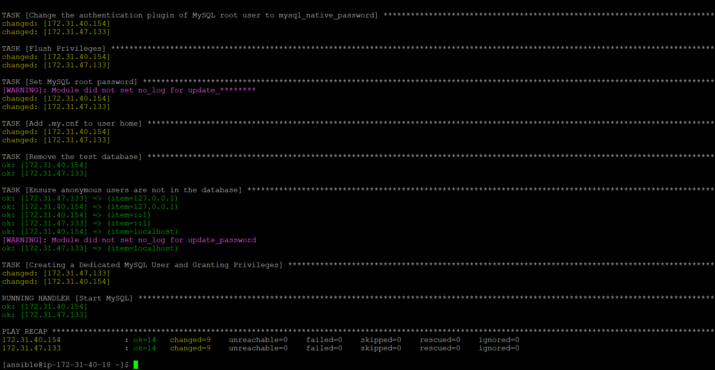

Checks:

**Node 01: MySQL running**

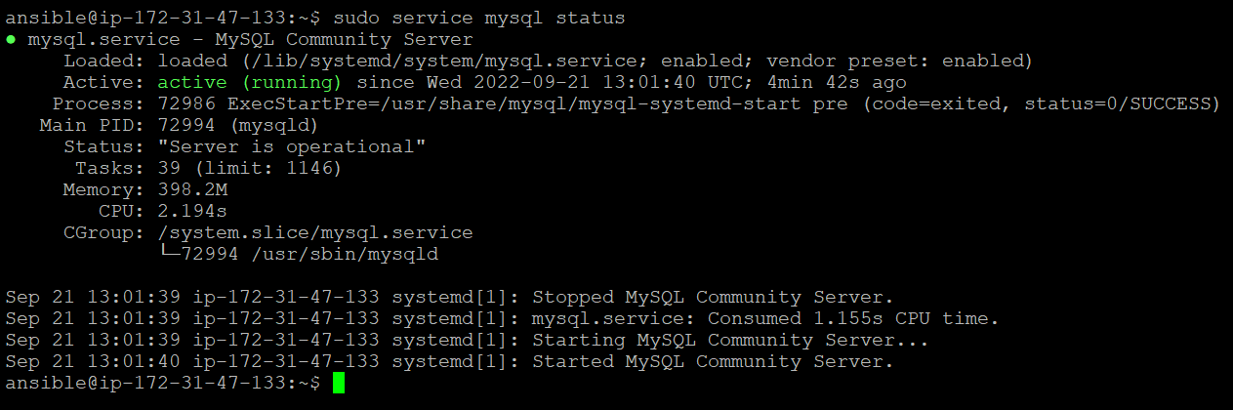

**Node 02: MySQL running**

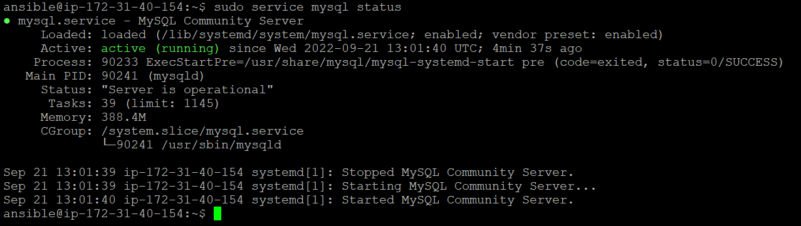

**Node 01: uthentication plugin of MySQL root user to mysql_native_password**

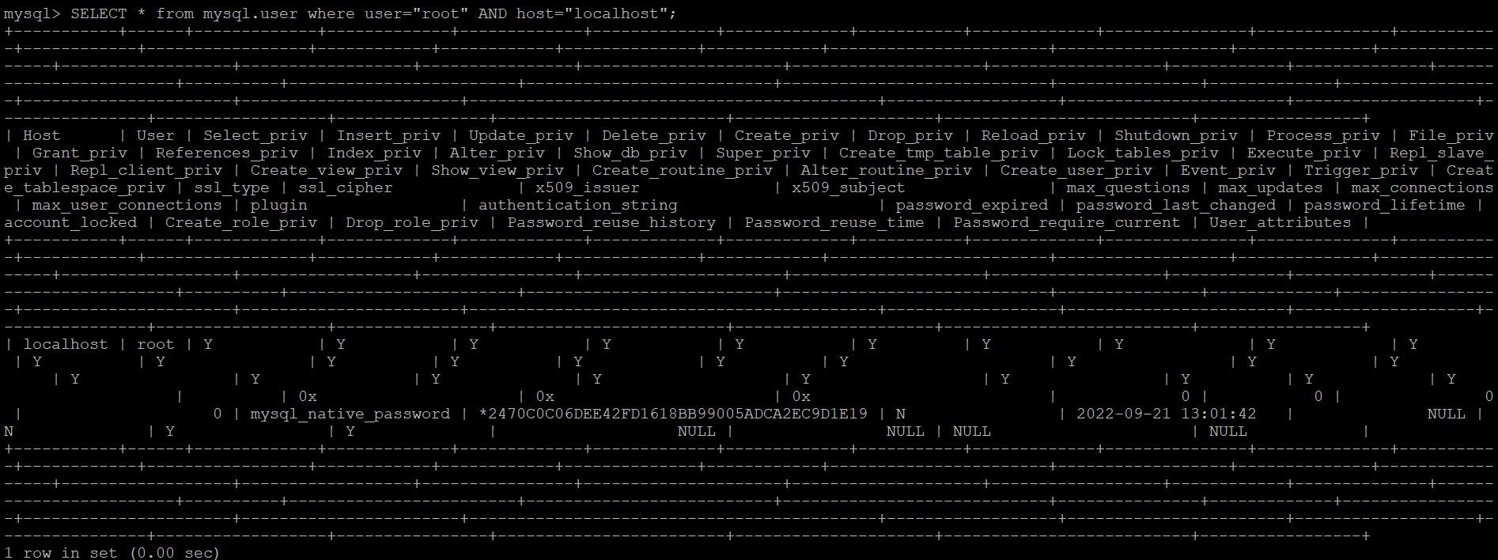

**Node 02: authentication plugin of MySQL root user to mysql_native_password**

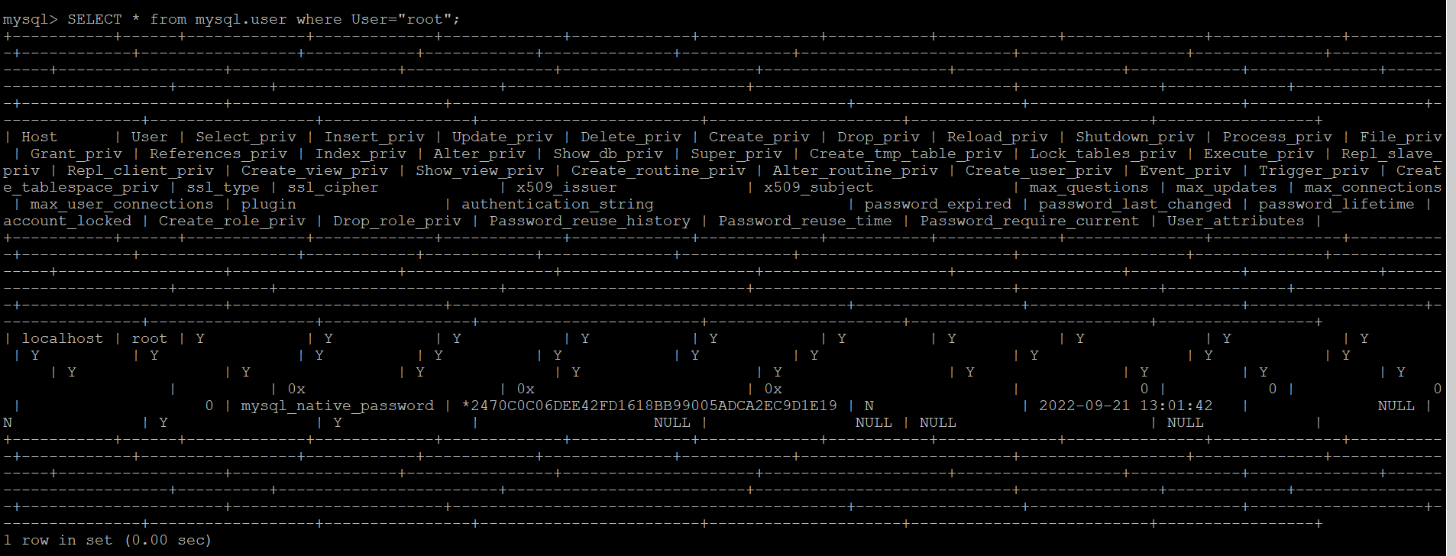

**Node 01: copy .my.cnf to root & removal of test database**



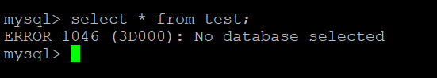

**Node 02: copy .my.cnf to root & removal of test database**

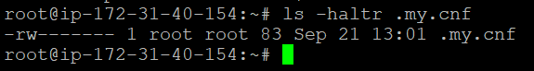



**Node 01: root and tanmayee user**

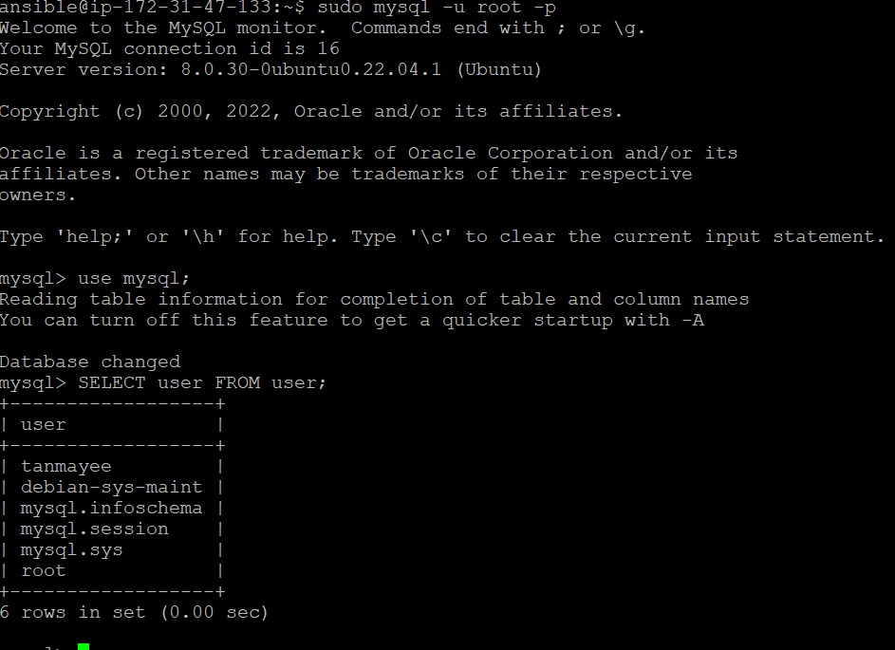

**Node 02: root and tanmayee user**

